Chi-Square Tests of Independence
For the tests of independence of two categorical variables, the chi-square test statistic is
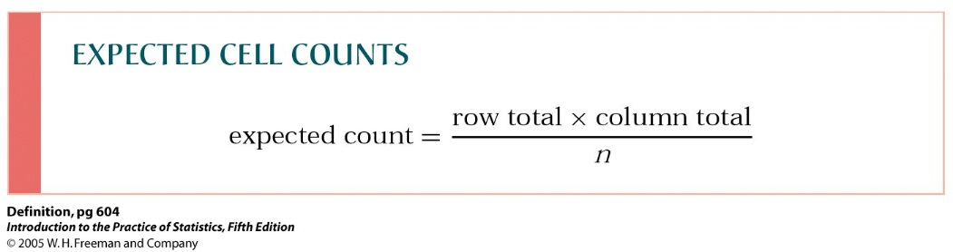
Where Observed are the actual counts, and Expected counts are calculated as
So, the test takes several steps:
- Arrange the observed counts in a table
Observed counts
Stratum | Sampled | NotAllowed | Total
Small | 57 | 6 | 63
Medium | 17 | 5 | 22
Large | 5 | 1 | 6
Total | 79 | 12 | 91

- Follow the formula for expected counts. For example, this command
=$D3*B$6/$D$6
gives the expected count in cell B3 (sampled small) = 54.69.
All my row totals are in column D, and all the row totals in row 3, so I added dollars $ and dragged the formula around the whole table.
Expected counts
Stratum | Sampled | NotAllowed | Total
Small | 54.69 | 8.31 | 63
Medium | 19.10 | 2.90 | 22
Large | 5.21 | 0.79 | 6
Total | 79 | 12 | 91

- Follow the formula for the chi-square components. For example,
=(B3-G3)^2/G3
computes the component for the cell “sampled small” = 0.10.
Chi-square components
Stratum | Sampled | NotAllowed
Small | 0.10 | 0.64
Medium | 0.23 | 1.52
Large | 0.01 | 0.06

- The chi-square statistic is the sum of chi-square components,
=SUM(B10:C12)

- The P-value can be computed as
=CHISQ.DIST.RT(E9,2)
The option RT gives the needed right-tail probability, and 2 stays for the degrees of freedom = (r-1)(c-1). You can also use the command
=1-CHISQ.DIST(E9,2,1)

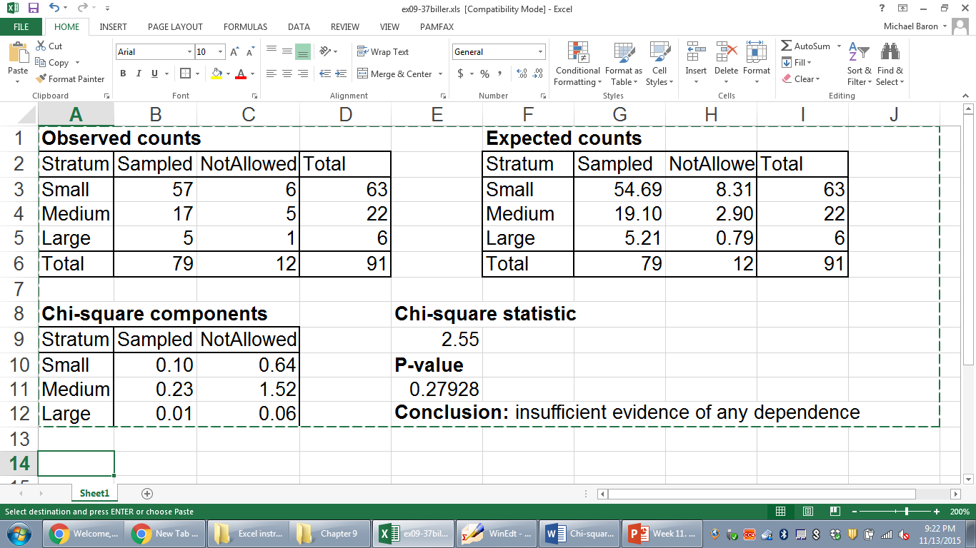

Steps 3-4-5 can also be accomplished by just one command
=CHITEST(B3:C5,G3:H5)
It returns the P-value of our chi-square test.
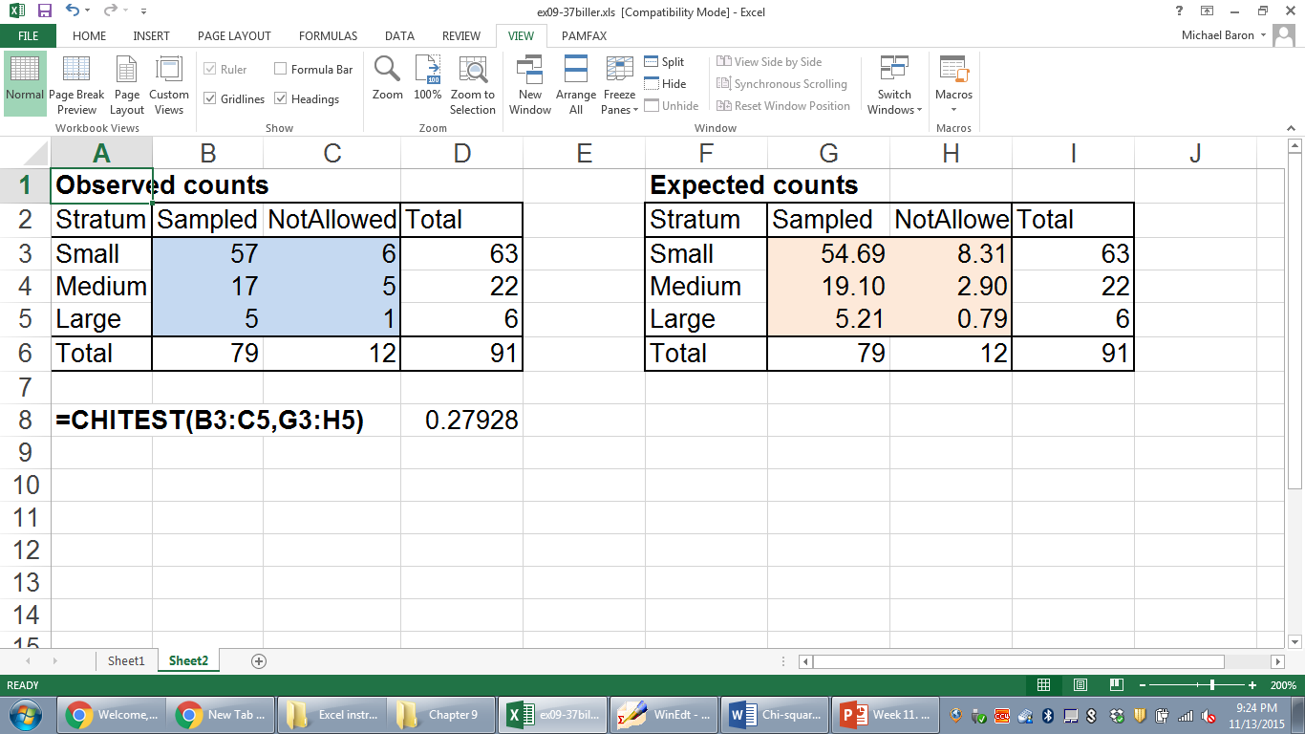
P-value

